**SWANA 2020**

**GRANT H. FLINT INTERNATIONAL SCHOLARSHIP AWARDS PROGRAM**

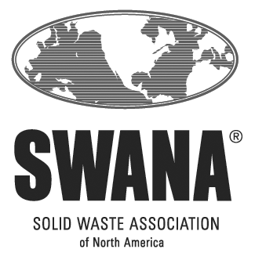

**The Robert P. Stearns/**

**SCS Engineers**

**Scholarship**

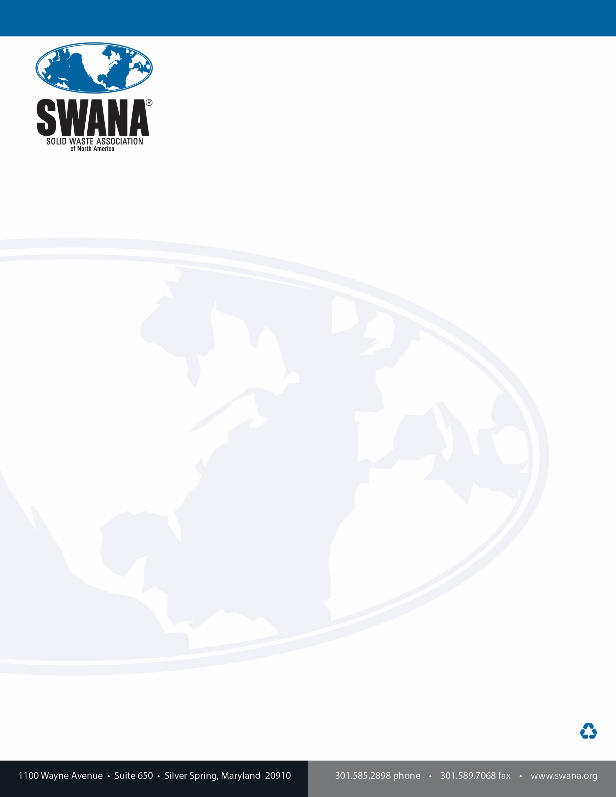

Dear Graduate Student:

Hello and thank you for your interest in the Robert P. Stearns/SCS Engineers Scholarship, offered through the Solid Waste Association of North America (SWANA).

Robert P. Stearns was co-founder of SCS Engineers, an employee-owned environmental consulting and construction firm that designs and implements sustainable environmental solutions. Until his death in 2013, Mr. Stearns was recognized nationally for his significant contributions to the environmental engineering profession and advancement of solid waste management practices.

SWANA is a professional association of more than 10,000 members who work in solid waste management. That industry is far advanced from the old stereotypes of “garbage men.” Our membership is diverse. We encourage you to consider how your selected area of study might lead you into our professional ranks. SWANA has a place for you.

To be eligible to apply for the Robert P Stearns/SCS Engineers Scholarship, worth up to $5,000 US, you must be:

* A full-time student entering or already in graduate school for the period of time the scholarship will be used
* Pursuing a degree in environmental science, environmental studies, engineering or other major applicable to the field of solid waste or resource management.
* Aa SWANA Student Member. The membership is free to full-time students and you can join by visiting [www.swana.org](http://www.swana.org).

**Applications are due to your Chapter Scholarship Committee Chair by May 1, 2020**. Chapters may have their own scholarship programs and are also responsible for sending a single chapter nomination for this scholarship to SWANA by June 1, 2020. SWANA’s awards will be announced during summer 2020.

Contact information for Chapter Scholarship Committee Chairs can be found at <https://swana.org/Awards/ScholarshipsInternships.aspx>. You will also find a link to many of the Chapter websites and information about their local scholarship programs. Members living outside the United States, its territories or Canada should complete the application and send it directly to Sara Bixby in her role as SWANA’s Staff Scholarship Administrator by May 1, 2020.

For more information, check with your Chapter Scholarship Chair or Sara Bixby at [sbixby@swana.org](mailto:sbixby@swana.org).

We look forward to receiving your application. Best of luck as you continue your education.

Sincerely,

|  |  |
| --- | --- |
| Mike Stringer | Sara Bixby |
| Chair, SWANA Scholarship Committee | Deputy Executive Director, SWANA |

**SWANA  
ROBERT P. STEARNS/SCS ENGINEERS SCHOLARSHIP   
APPLICATION INFORMATION**

1. **AWARDS:**

Depending on the number and quality of applications, SWANA and SCS Engineers intend to make an award of $5,000 US this year.

1. **ELIGIBILILTY:**

To be eligible to apply for the Robert P. Stearns/SCS Engineers Scholarship, worth $5,000 US, you must satisfy all the following requirements:

* Be a full-time student entering or already in graduate school for the period of time the scholarship will be used
* BE pursuing a degree in environmental science, environmental studies, engineering or other major applicable to the field of solid waste or resource management.
* Be a SWANA Student Member. Membership is free to full-time students and you can join by visiting [www.swana.org](http://www.swana.org).

SWANA employees and their family members are not eligible to apply. Beyond those exceptions, SWANA commits that all eligible persons shall have equal access to this program.

**DEADLINES:**

* **May 1** - All completed application forms and back-up documentation must be received by your Chapter Scholarship Committee Chair.
  + Students can join two chapters for free.
    - Join the chapter where your school is located. Submit your application there.
    - If you have an internship or work assignment in a different chapter area, check into their activities and programs as those new relationships can lead to additional support for your application.
  + If you are geographically located outside the United States, its territories or Canada, send your completed application directly to SWANA’s Staff Scholarship Administrator by May 1, 2020.
* **June 1** – Chapters forward their nomination for scholarships to headquarters for distribution to the International Scholarship Committee.
* **July/August** - International Scholarship winners are announced.

1. **CRITERIA:**

The Scholarship Committee evaluates the Robert P. Stearns/SCS Engineers Scholarship applications as follows:

1. **Academics = 30%**

SWANA’s Scholarship Committee considers past academic performance an important selection criterion. Your application must provide enough information to allow the Scholarship Committee to evaluate your academic performance.

* REQUIRED: Provide a transcript of your college/university transcripts through the conclusion of the most recent period (quarter, trimester, semester).
* REQUIRED: Provide a copy of your acceptance letter to graduate school if this will be your first year attending that school.
* REQUIRED: Identify any degrees currently held and provide graduation verification.

An official, unofficial or PDF copy of your transcript is required to be attached to the application you provide to the Chapter or SWANA. The transcript must provide marks for all courses and a measure of your academic performance when measured on the school’s standardized scoring system. Identify the scale used (e.g., 4.0 on a 4.0 scale). An example of one possible measure satisfying this request for U.S. based students is grade point average (GPA). SWANA acknowledges that not all schools use this measure and will accept other measures ***documented by the transcript***.

International graduates attending school in the United States and Canada can ask their current school for copies of foreign transcripts/academic records and graduate verification as this may help simplify and speed the process of gaining access. If you must contact your prior university for material, be sure to allow sufficient time to receive a response (may take several weeks).

* OPTIONAL: Attach documentation of any other college/university-level **academic** **performance, awards, or recognition** and/or letters of recommendation related to academic performance you believe the Scholarship Committee should consider.

1. **Relationship of Studies to Solid Waste Management = 60%**

The Committee will consider your current and completed courses, advisor/professor input, and your completed essay in its evaluations.

* REQUIRED: Complete and sign the form that asks for additional information about coursework related to solid waste management and/or a potential career in the industry.
* REQUIRED: Please have your faculty advisory or a key professor in your studies related to solid waste management provide a one-page letter that discusses your academic performance.
* REQUIRED: If involved in a research program or an internship/assistantship, please have your faculty advisor provide documentation regarding the nature of the project and your participation and performance.
* REQUIRED: Write a one-page, original essay about the topic identified in Question 4. SWANA considers essays as potential blog posts in its social media, regardless of selection for a scholarship.
* OPTIONAL: Include links to published articles or a short bibliography, if available. Large data files transmitting full copies of books and papers are specifically not required and add less to the Committee’s review than a succinct summary or link.

1. **Other Activities = 10%**

Other Activities are activities and programs that can be connected with your studies (research, internships, assistantships), associated with school (participation student organizations), or entirely unrelated (volunteer activities, military service, employment).

* REQUIRED: Complete and sign the forms that ask for information about your Other Activities.
* OPTIONAL: Attach documentation and/or letters of recommendation to help the Scholarship Committee appropriately score this part of your application
* OPTIONAL: Attach a current copy of your resume

1. **Financial Need – not weighted**

OPTIONAL: Although it is not a weighted factor, the Scholarship Committee can take financial need into consideration. Please do not attach forms that contain confidential personal information.

1. **Disqualification**

Applying is not a guarantee of funding. The Scholarship Committee may disqualify an application for any of the following reasons.

* Applicant fails to meet the May 1 deadline for submitting the application to the Chapter or Staff Scholarship Administrator
* Chapter fails to provide its recommendations to SWANA by the June 1 deadline
* Applicant will not be enrolled in classes in the coming semester
* Does not provide all REQUIRED supporting documentation and letters
* Contains an essay or substantial parts of an essay written by another person
* Is not legible
* Is not signed by the applicant where indicated

1. **QUESTIONS:**

We realize there may be questions that aren’t answered by this overview. Please direct your questions to your **Chapter’s Scholarship Chairperson** or **SWANA’s Staff Scholarship Administrator,** Sara Bixby at [sbixby@swana.org](mailto:sbixby@swana.org).

**ROBERT P. STEARNS/SCS ENGINEERS SCHOLARSHIP**

**APPLICATION**

|  |  |  |
| --- | --- | --- |
| **1** | **Applicant’s Information** | |
|  | **Full Name:** |  |
|  | **Address:** |  |
|  | **Telephone:** |  |
|  | **Email:** |  |
|  | **SWANA Member #:** |  |
|  | **Chapter Affiliation:** |  |

|  |  |  |  |  |  |  |  |  |
| --- | --- | --- | --- | --- | --- | --- | --- | --- |
| 2 | **Academics = 30% of Total Score** | | | | | | | |
|  | **Degrees Currently Held** | | | | | | | |
|  | **Degree:** | |  | | **Degree:** |  | | |
|  | **Major:** | |  | | **Major:** |  | | |
|  | **Year:** | |  | | **Year:** |  | | |
|  | **School:** | |  | | **School:** |  | | |
|  | **Degree:** | |  | | **Degree:** |  | | |
|  | **Major:** | |  | | **Major:** |  | | |
|  | **Year:** | |  | | **Year:** |  | | |
|  | **School:** | |  | | **School:** |  | | |
|  | **Graduate School you are or will attend under this scholarship:** | | |  | | | | |
|  | **Department Address:** | | |  | | | | |
|  | **Telephone:** | | |  | | | | |
|  | **Area of Study:** | | |  | | | | |
|  | **Working Toward:** | | | Masters ____ | | | | PhD ___ |
|  | **Expected Graduation** | | | Month | | | Year | |
|  | REQUIRED: | | | | | | | |
|  |  | Provide a copy of college/university transcripts through the conclusion of the most recent period (quarter, trimester, semester). | | | | | | |
|  |  | Provide graduation verification for schools from which degrees are reported. | | | | | | |
|  |  | Provide a copy of your acceptance letter to graduate school if this will be your first year attending that school. | | | | | | |

|  |  |  |
| --- | --- | --- |
| **4** | **Relationship of Studies to Solid Waste Management = 60% of total score** | |
|  | **REQUIRED: All three items must be included with your application.** | |
|  |  | Complete and sign the forms that ask for additional information about coursework, internships, and research related to solid waste management and/or a potential career in the industry. |
|  |  | Attach a letter about your academic performance from your faculty advisor or key professor in your studies related to solid waste management. |
|  |  | Attach a one-page, original essay about the way in which your course work, internships, and/or overall studies will contribute to improving the management of waste as a resource or to addressing an environmental issue related to solid waste that is currently in the news. |
|  | **OPTIONAL/If Available:** | |
|  |  | If involved in a research program or an internship/assistantship, please have your faculty advisor provide documentation regarding the nature of the project and your performance. |
|  |  | Provide links to published articles or a short bibliography. Large data files transmitting full copies of books and papers are specifically not required and add less to the Committee’s review than a succinct summary or link. |

|  |  |
| --- | --- |
| **5** | **Other Activities = 10% of total score** |
|  | **REQUIRED:** Complete and sign the forms that asks for information about your Other Activities. If you do not participate in Other Activities, sign the bottom of the blank page. |
|  | **Optional:** Attach documentation and/or letters of support that will help the Scholarship Committee appropriately score your application. |
|  | **Optional:**  Attach a current copy of your resume. |

|  |  |
| --- | --- |
| **6** | **Financial Need: not weighted** |
|  | You may attach a short statement of your financial need, describing how this scholarship will help offset tuition and related expenses and listing any other scholarships or educational funding received to-date. Please do not attach forms or other documented containing confidential personal information. |

|  |  |
| --- | --- |
| Signature of Applicant | Date |

**ROBERT P. STEARNS/SCS ENGINEERS SCHOLARSHIP**

***Description of Completed Courses Related to Solid Waste Management***

**Please provide the course title, credit hours, grade earned, and up to a 25-word description of your course work that relates to solid waste management and/or a career in the industry. Copy the page if you need more space.**

|  |  |
| --- | --- |
| **Course Title:** |  |
| **Credit Hours:** |  |
| **Grade:** |  |
| **Description:** | |
| **Course Title:** |  |
| **Credit Hours:** |  |
| **Grade:** |  |
| **Description:** | |
| **Course Title:** |  |
| **Credit Hours:** |  |
| **Grade:** |  |
| **Description:** | |
| **Course Title:** |  |
| **Credit Hours:** |  |
| **Grade:** |  |
| **Description:** | |

I, ______________________________, verify that the information above is true to the best of my knowledge.

**ROBERT P. STEARNS/SCS ENGINEERS SCHOLARSHIP**

***Current or Completed internships and Assistantships***

**Provide enough information to allow the Committee to what you did and its relevance to solid waste management. Please limit your description to no more than 250 words. Copy the page as needed to address additional internships and assistantships.**

|  |  |
| --- | --- |
| **Internship/Assistantship** |  |
| **Supervisor & contact information** |  |
| **Description:** | |
| **Internship/Assistantship** |  |
| **Supervisor & contact information** |  |
| **Description:** | |

I, ______________________________, verify that the information above is true to the best of my knowledge.

**ROBERT P. STEARNS/SCS ENGINEERS APPLICATION**

***Documentation of Current or Completed Research Efforts***

**Please describe the nature and purpose, research protocol, schedule status, results to date, any anticipated practical application, and any publications resulting from your current and/or completed research project(s). Sign each description and provide the name of your faculty advisor/supervisor for each.**

I, ______________________________, verify that the information above is true to the best of my knowledge.

**ROBERT P. STEARNS/SCS ENGINEERS APPLICATION**

***Other Activities***

**Other activities are activities and programs that can be connected with your studies, school participation, or entirely unrelated (volunteer activities, military service, employment). Provide enough information that Committee members can understand your participation. Keep it brief and copy the page if you need more space.**

|  |  |
| --- | --- |
| **Activity** |  |
| **Duration & frequency** |  |
| **How did you participate?** | |
| **Activity** |  |
| **Duration & frequency** |  |
| **How did you participate?** | |
| **Activity** |  |
| **Duration & frequency** |  |
| **How did you participate?** | |
| **Activity** |  |
| **Duration & frequency** |  |
| **How did you participate?** | |
| **Activity** | |
| **Duration & frequency** |  |
| **How did you participate?** | |

I, ______________________________, verify that the information above is true to the best of my knowledge.

**Have you attached:**

* College/university transcripts and graduation verifications - required
* Documentation of academic achievement, awards, and honors – applicant specific
* All forms - required
* Letter(s) from your faculty advisor or key professor – required
* One-page essay on the topic identified in Question 4 – required
* Any other material you wish the Committee to consider - optional
* Resume – optional

By May 1, return your complete application to your Chapter Scholarship Chair, <https://swana.org/Awards/ScholarshipsInternships.aspx> , or if you are geographically located outside the United States, it territories, or Canada, send your completed application directly to SWANA’s Staff Scholarship Administrator.